**B-BBEE & Food Safety Certificate Supplier Portal Guide**

**Contents**

* **B-BBEE Certificate.......................................................................................................................................pg. 1**

**Company not Required to or Not Submitting B-BBEE Certificate………………………………………………………………..pg. 2**

**B-BBEE Certificate**

When a User logs into the Supplier Portal on behalf of the Company a pop-up message will appear, this message will advise that a B-BBBEE Certificate needs to be uploaded for the Company. this is only for South African based Suppliers.

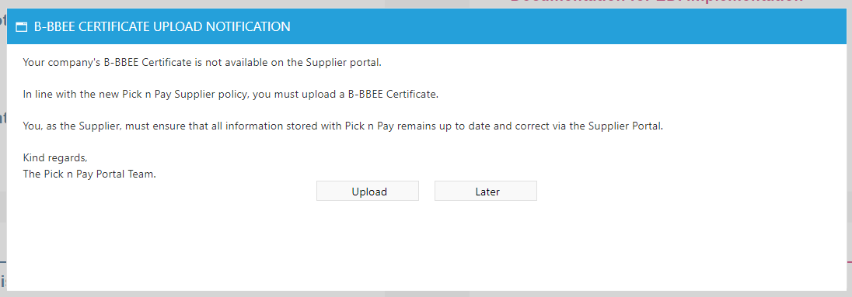

B-BBEE Certificate Registration for Supplier is to complete online, you will be able to access the page with “Upload” button on the earlier pop-up message or via the “Submit Trade Documents” link under the Supplier Maintenace Section on the Supplier Portal.

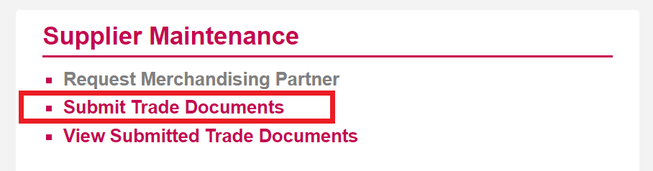

On the B-BBBEE Certificate Registration Screen, your Company Name will be entered by default, select the appropriate VAT number for the Company if there are multiple to choose from.

Complete all fields with the information form the B-BBEE Certificate and then upload a pdf copy of the Certificate. All fields are mandatory.

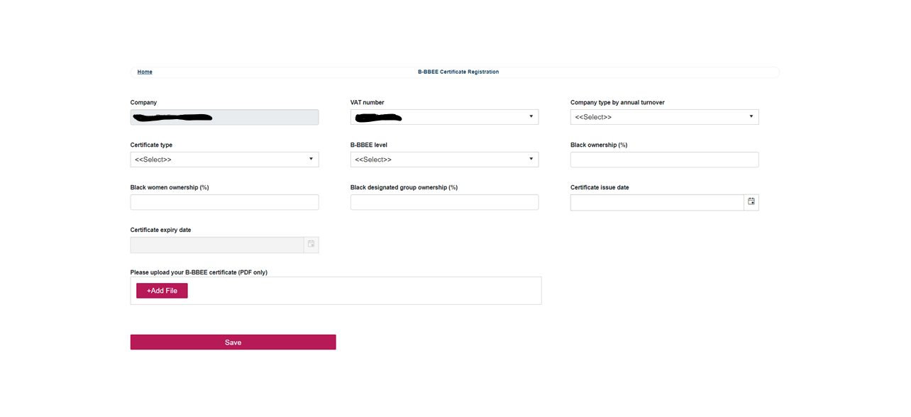

The Certificate along with the Submitted information with be sent to the PnP Representative in the B-BBBEE department.

A Review of B-BBEE Certificates Submitted can be found under the link “View Submitted Trade Documents” under the Supplier Maintenance Section on the Supplier Portal.

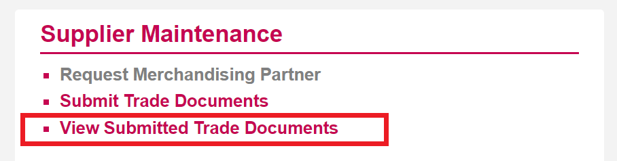

Below is an example of a submission, it will show the status of the Certificate, who sent the B-BBEE Certificate and when.

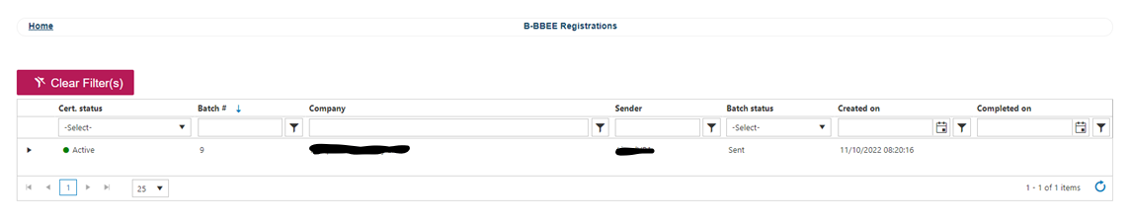

**Company not Required to or Not Submitting B-BBEE Certificate**

If you Company is not required to submit a B-BBEE Certificate or is choosing not to submit a B-BBEE Certificate, below is an example on how to complete the submission, you will be required to upload a letter from the Company confirming the stance.

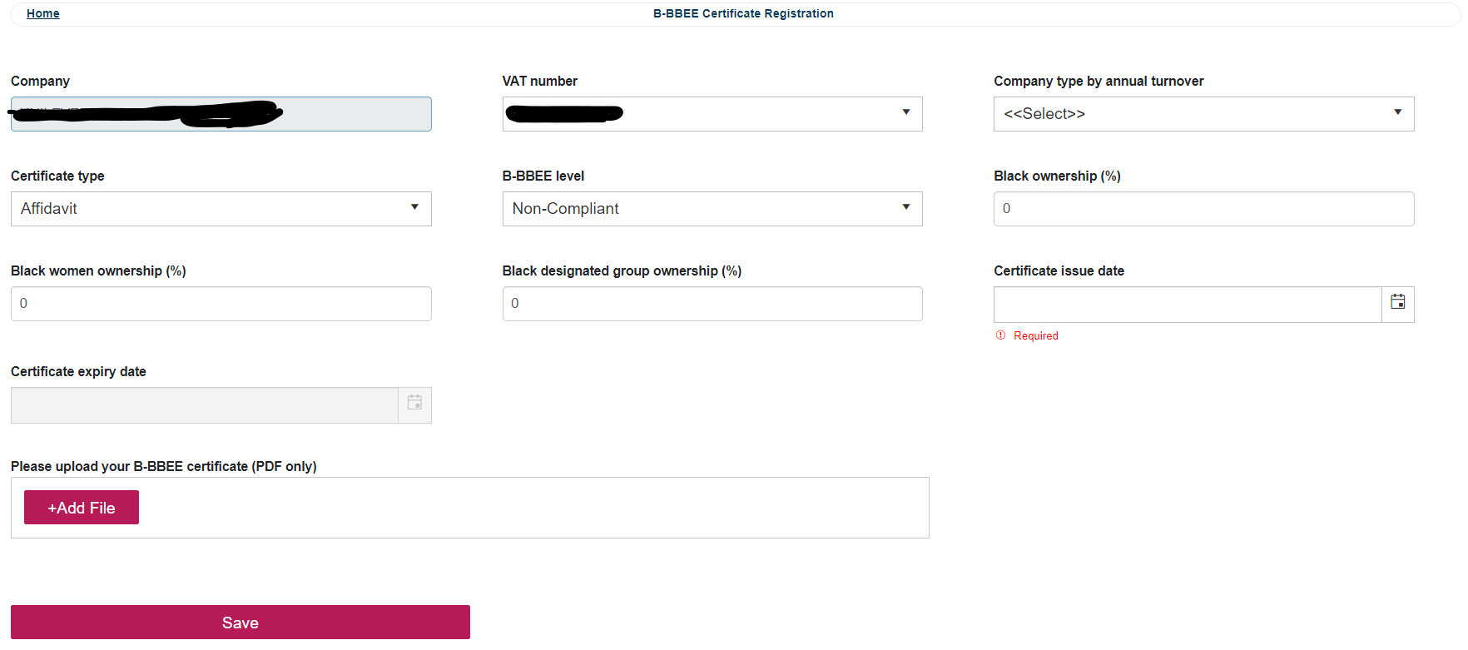

Today’s Date